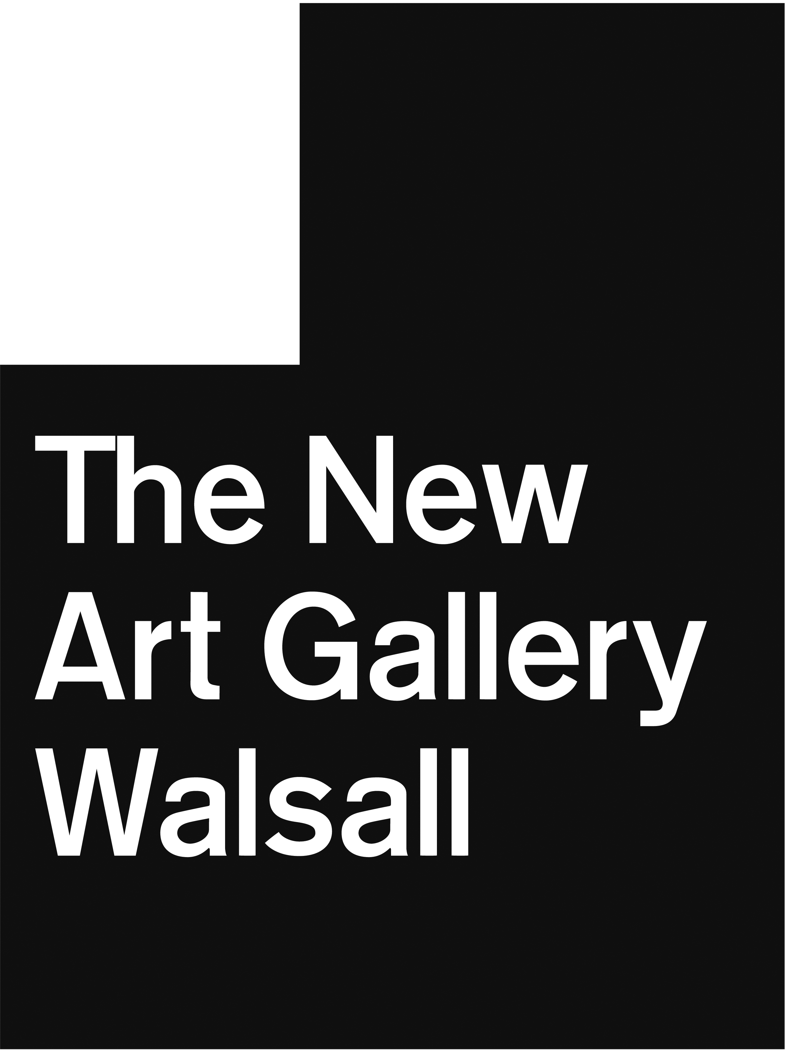
Chris Clinton
Dead Media
17 January – 6 April 2014

Chris Clinton uses familiar objects and reclaimed materials to create artworks that refer obliquely to contemporary popular culture and our disregard for out-dated media such as videotapes. His most recent works are made by deconstructing and reforming novelty paper-coil dartboards to create new objects that act as “portraits” of the subjects they represent. This exhibition brings together for the first time the artist’s full series of dartboards, alongside two new sculptures commissioned by The New Art Gallery Walsall.

Clinton sources his dartboards from internet auction sites before unwrapping the coiled paper and reforming the dartboard to create new wall-based artworks. The references to Hollywood films, comic books, cartoons, bands and consumer brands only remain in the dartboard titles, which include The Bone Collector, The Simpsons, Spiderman, Iron Maiden, and Guinness. The original dartboard image is completely destroyed in the re-wrapping process, reminding us of the fleeting lifespan of novelty items.

The exact outcome of Clinton’s process is impossible to predict because the artist can never manipulate the paper to achieve the coil tightness of the machine-manufactured dartboard. Elements of the original printed image are lost during the re-coiling process to reveal colourful concentric circles and geometric patterns while new bumps and imperfections emerge across the dartboard surface. These draw attention to the materiality of the paper and testify to the limitations of the human hand. The finished dartboards recall Jasper Johns’ series of Target paintings made between 1958 and 1961 and highlight the close relationship of painting to sculpture.

This relationship is also explored in a domestic-sized sculpture at the gallery’s entrance. Made by reworking an old table frame, the structure resembles a plinth in shape and scale. Here the plinth is used to contain and “frame” a selection of painted canvas rolls. Wrapped in plastic tube sleeves, the rolls resemble fablon/vinyl off-cuts or commercial posters but are, in fact, samples of the artist’s “failed” paintings. By removing his painting from its stretcher and reframing it within a plinth, the artist calls into question the traditional division between painting and sculpture.

Illuminated by natural light from the roof terrace, another sculpture, Dead Media Format, is spectacularly realised using a found market stall frame and the tape from multiple reels of VHS magnetic tape. The work refers to Walsall’s history as a market town but by destroying the functionality of the frame and polishing out all traces of the object’s history, the artist has transformed a commonplace utility item into something that evokes the splendour of an eighteenth century Chinoiserie cabinet.

The choice of mass-produced VHS cassettes is significant to the artist due to the format’s current low value status. Though superseded by DVD and abundantly available in charity shops the videotape is not yet redundant or outmoded enough to be collectible or capable of attracting the retro cult that presently surrounds vinyl. By unravelling the tape and thereby erasing the information stored, the artist draws attention to the more physical qualities of the reflective magnetic tape such as glitches and graduations in colour. Through stretching and wrapping the material a shiny lacquer-like surface is produced, suggesting the former grandeur of a media in decline.

A time lapse film documenting the construction of Dead Media Format can be viewed downstairs in the foyer. Pick up a key to works for further information on the dartboard titles.

In Conversation
Saturday 22 March, 2pm
Join the artist for an informal introduction to his exhibition and working process.

Book your free place in advance at The New Art Gallery Walsall reception or by calling 01922 654400.

